**A notification and shutdown system for water pumps**

**using Internet of Things (IoT) technology.**

Princess Chulabhorn Science High School Nakhon Si Thammarat 6305546@pccnst.ac.th

Abstract

This project aims to develop a notification and automatic shutdown system for water pumps, utilizing Internet of Things (IoT) technology. The main objective is to prevent damage caused by irregular operating conditions, such as dry runs or excessive energy use. The system features a flow switch to monitor water flow and a PZEM-004T sensor to measure electrical current. Data from these components is processed by the NodeMCU ESP8266 microcontroller, which displays the information on an LCD screen and through the Blynk Legacy application. Users receive real-time alerts via the Telegram Notify service.

The experiment involved programming the ESP8266 to monitor sensor data, detect irregularities, and control the relay module to cut off power to the pump when necessary. Results showed that the system effectively identified abnormal conditions and responded promptly by sending notifications and safely shutting down the pump. Furthermore, it provided users with an easy-to-use interface for adjusting parameters such as flow delay, current limits, and shutdown procedures.

In conclusion, the system achieved its goal of improving safety, reducing maintenance costs, and enhancing water usage efficiency. It is suitable for residential, agricultural, and industrial applications, with opportunities for future improvements, such as cloud-based data logging and support for multiple pump systems.

**Keywords :** Internet of Things; ESP8266; Telegram Notify

1. Introduction

Water pumps are used in daily life, especially in households, agriculture, government agencies and private organizations. These pumps run continuously. But a common problem is when the pump is running but not delivering any water, a situation known as "Dry Run". This can damage the pump and waste electricity. From our experience in our village, we found that this problem happens often, that’s why we decided to study and solve the problem through this science project.

Dry Run problems have been discussed in many studies and research papers. For example, a study by Ittichai Rodkwan, Pongkana Mahasawat, and Watcharin Krainara (2019) developed an automatic irrigation system for salacca plantations using IoT technology. Their system can monitor soil moisture and control water pumps through Blynk application, and send alerts via TELEGRAM Notify. This can reduce equipment damage and improve efficiency. If this problem is not solved, it can cause expensive repair and even electrical fire. With the advancement of Internet of Things (IoT) technology, we can now monitor and control devices remotely. This can shut down the pump automatically in abnormal condition, save energy and reduce maintenance cost.

The goal of this project is to develop a smart system that can detect pump issues like Dry Run and automatically stop the pump. The system will also send real-time notification to user and record usage data for further analysis. We hope this project will help prevent pump damage and support safer and more efficient water use.

1. Literature Review

A study by Ittichai Rodkwan, Pongkana Mahasawat, and Watcharin Krainara (2019) presented an Automatic Online System for the Watering Controls in Salacca Plantations. They developed a smart irrigation system using soil moisture sensors, Arduino Mega 2560 and Blynk for remote control. The system can auto irrigation based on soil data and notify user via Telegram when anomaly occur. This is related to our project’s focus on real-time monitoring and alerting to prevent Dry Run in water pumps.

One of the issue in pump operation is detecting abnormal electrical consumption that indicate Dry Run condition. In our project, this is solved using PZEM-004T power monitoring sensor. The power consumed by the pump can be calculated using the formula : *P = V × I × PF* Where *P* is the real power in watt, *V* is voltage, *I* is current in ampere, and *PF* is the power factor. If the calculated power deviate significantly from the expected range, it can indicate that the pump is running without water or electrical problem. These data is crucial to trigger auto shutdown through NodeMCU ESP8266 and relay module.

IoT also play a big role in automation and communication. Blynk Legacy app provide graphical interface for user to monitor and adjust system setting via smartphone, while Telegram Notify API provide real-time alert. A study by Siriwan Joranan, Thidarat Kongsawat, and Nonthawat Chansan (2021) applied similar approach in IoT system for controlling environmental condition in bird breeding which include alert notification and remote monitoring.

Based on the literature review, it is clear that IoT-based monitoring system is effective in detecting anomaly, reduce system damage and improve overall efficiency. These study confirm the feasibility of integrating flow sensor, power monitoring module and alert system into one platform for water pump protection. This background support the direction and design of this science project.

1. **Methodology**

To solve the problem of Dry Run in water pumps, the team designed and developed an IoT based system that can detect water flow and electrical current anomalies, send real time alerts and auto shut down the pump when needed. The methodology consists of 4 stages: research and planning, system design, system implementation and testing and evaluation.

1. Research and Planning

The team started by studying the theory and components, centrifugal water pumps, Flow Switch sensors, PZEM-004T power sensors, NodeMCU ESP8266 microcontrollers. Previous research and case studies were reviewed to design a system that suits real world conditions.

2. System Design

The design phase involved both hardware and software components

Flow Switch detects if water is flowing through the pipe.

PZEM-004T measures electrical current used by the pump.

NodeMCU ESP8266 receives sensor data, processes the logic and controls the Relay Module to shut down the pump if necessary.

Notifications are sent via Telegram Notify, and system status is shown via Blynk Legacy and LCD screen.

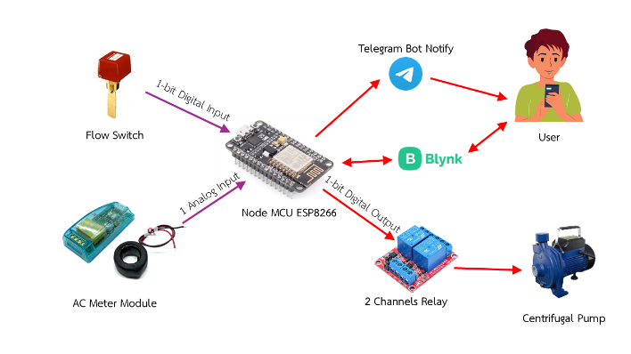

Figure 1 Hardware System Architecture

3. System Implementation

Components were assembled inside a plastic control box. Flow Switch was connected to water pipe outlet, and relay module was wired to control the pump’s power. System was programmed using Arduino IDE, and NodeMCU was connected to WiFi for Telegram and Blynk functionality.

Conditions Set

FD (Flow Delay): If no water is detected for a user defined duration (e.g. 5 seconds) the system will send alert and shut down the pump.

AD (Amp Delay): If current exceeds threshold (e.g. 3.5A) for more than 3 seconds the system will shut down.

AMP Limit: User defined maximum current (e.g. 3.5A).

Protect Mode: If ON the system will auto shut down.

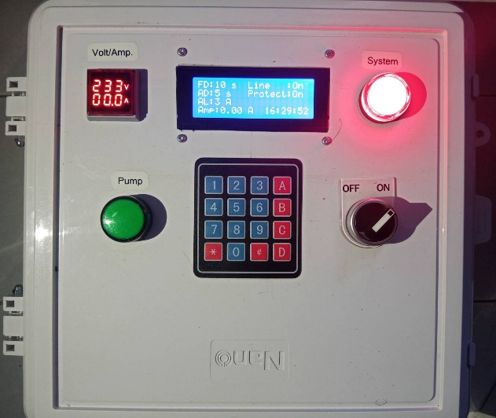

Figure 2 Front View of the Device

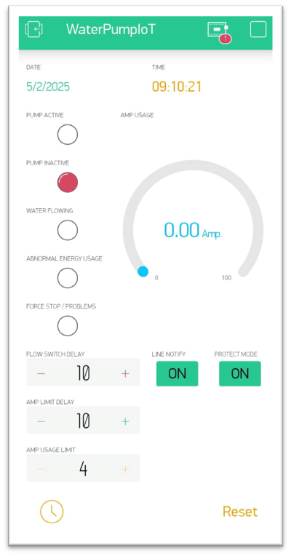

Figure 3 User Interface in Blynk Application

4. Testing and Evaluation

Multiple test cases were done

Normal Operation: Pump runs with proper flow and acceptable current.

Dry Run Simulation: Water source disconnected → no flow detected → system shut down after FD delay.

Overcurrent Simulation: Artificial load added to pump → current exceeded AMP limit → system shut down after AD delay.

Each test confirmed that the system responded correctly to abnormal conditions and sent real time alerts and auto shut down reliably.

Figure 4 Telegram Bot for System Notification Alerts

ตารางที่ 1 แบบอักษรและขนาดสำหรับส่วนต่าง ๆ ของบทความ

|  |  |  |
| --- | --- | --- |
| **องค์ประกอบ** | **รูปแบบ** | **ขนาด** |
| ชื่อบทความ | ตัวหนา | 16 |
| ชื่อผู้เขียนบทความ | ตัวหนา | 12 |
| สถาบันต้นสังกัดของผู้เขียนบทความ | ตัวธรรมดา | 12 |
| หัวข้อ (ทุกระดับ) | ตัวหนา | 14 |
| เนื้อหาและบทคัดย่อ | ตัวธรรมดา | 12 |
| เนื้อหาในตาราง | ตามความเหมาะสม | 10-12 |
| ป้ายชื่อรูปและตาราง | ตัวธรรมดา | 12 |

ตัวอย่างรูปภาพสี่เหลี่ยม

รูปที่ 1 ตัวอย่างรูปภาพที่ใช้ในบทความ

สแกนรูปถ่าย

2 cm x 2 cm

1. Results and Discussion

ผลการทดลอง เป็นการรายงานผลข้อมูลในรูปตาราง ตารางออกแบบให้มีข้อมูลครบกะทัดรัด ข้อมูลต้องสัมพันธ์กันในตาราง

การอภิปราย เป็นการแปลผลข้อมูลในลักษณะตีความและประเมินผลเพื่ออธิบายยืนยันความสอดคล้องและความแตกต่างกับงานที่เคยมีผู้ทำมาก่อน

1. สรุป (CONCLUSION)

ผู้เขียนสรุปภาพรวมการทำโครงงานวิทยาศาสตร์ให้มีความสอดคล้องกับปัญหา เป็นไปตามผลการทดลองที่เกิดขึ้น และแนวทางการพัฒนาต่อยอดโครงงาน

1. กิตติกรรมประกาศ (ACKNOWLEDGMENT)

This project was made possible by many people and wouldn’t have been done without each and every one of them. We would like to say thank you very much to Ms. Kusolin Thipmanosingh, a Computer Science teacher at Princess Chulabhorn Science High School Nakhon Si Thammarat, and Mr. Thapanawat Chooklin, our project advisor, for guiding us throughout the project, lending us equipment and tools, and feeding us, giving us drinks and encouragement throughout the process.

We would also like to thank Mr. Wichai Rajtanee, the principal of Princess Chulabhorn Science High School Nakhon Si Thammarat, and all the teachers and staff for their support, encouragement and facilitation. Their help made this project possible.

We would also like to thank our friends, seniors and juniors at Princess Chulabhorn Science High School Nakhon Si Thammarat for being our source of encouragement to finish this project. Their support, guidance and suggestions were very helpful throughout the process. If there’s any mistake or shortcoming in this project, we apologize.

เอกสารอ้างอิง (REFERENCES)

เป็นการบันทึกที่มาข้อความหรือเอกสารงานวิจัยที่เกี่ยวข้องมากล่าวอ้างเพื่อให้ผู้อ่านทราบแหล่งที่มาและเป็นการให้เกียรติกับเจ้าของแหล่งข้อมูล

ตย.

1. กลุ่มสถิติการขนส่ง กองแผนงาน กรมการขนส่งทางบก, “สรุปรายงานการวิเคราะห์ข้อมูลสถิติการเกิดอุบัติเหตุจราจรทางบก รอบ 12 เดือน,” กันยายน 2562.
2. สำนักงานเครือข่ายลดอุบัติเหตุ. บทความเพื่อความปลอดภัยทางถนน. [ปีที่พิมพ์ 2563; เข้าถึงเมื่อ 2565 มิถุนายน 9]. เข้าถึงได้จาก: http://www.accident.or.th.
3. B. Chan and R. Duran, “Bike Safe An Automatic Turn Signal System,” 2014, Senior Project, California Polytechnic State University, San Luis Obispo.
4. A.I. Alam, M. Rahman, S. Afroz, M. Alam, J. Uddin, and Md.A. Alam, “IoT Enabled Smart Bicycle Safety System,” Joint 7th ICIEV and 2nd icIVPR, February 2019.
5. L.W. Chen and C.Y. Cho, “BiLight: A Smart Bicycle Monitoring and Finding System for Rider Safety Based on IoT Technologies,” IEEE International Conference on PerCom Workshops: Demos, 2022, pp. 100-102.

**ประวัติผู้เขียนบทความ** ให้ผู้เขียนบทความทุกท่านเขียนชื่อ ประวัติโดยย่อยและงานที่สนใจพร้อมทั้งสแกนรูปถ่ายใส่ในกรอบสี่เหลี่ยม

สแกนรูปถ่าย

2 cm x 2 cm

สแกนรูปถ่าย

2 cm x 2 cm